Dear entrepreneur,

We are delighted to invite you to apply for a prestigious presentation slot at the 13th edition of the Tech Tour Contest Final on 9-10 December, in Essen, Germany.
The event has the European Commission as institutional partner, is co-hosted by EWG Essen and InvestHorizon.eu, and sponsored by the European Innovation Council, NRW.Bank, BioCampus Cologne, IHK Koeln, Ruhr:HUB, Evonik, Tengelmann, RAG-Stiftung and E.ON, and supported by Eureka.
The Contest Final is the culmination of Tech Tour’s series of 2019 regional and sector focused contests and forums, being Europe's leading network and investment event uniting 120+ award winning entrepreneurs and 150+ investors.

Companies from the NRW region active in the sectors of Digital, Foodtech, Healthcare and Sustainability have the exclusive opportunity to get a fast track to the Contest Final, being selected online by a Selection Committee of investors and corporate representatives.
You can see the list of already confirmed attending investors here.

To increase your chances to be selected and present at the Tech Tour Contest Final, Tech Tour together with BioCampus Cologne and IHK Koeln organizes for you the NRW Venture Academy, taking place on November 4th at Bio Campus Cologne.

The NRW Venture Academy is a full day of Investor Readiness preparation run by selected international and local mentors fine-tuning business models and sharpening business propositions of the participating entrepreneurs. The workshop will provide you with necessary tools to obtain funding, grow, and make the most out of the Contest Final.
At the Academy you will also have the opportunity to learn more about the Invest Horizon programme, an accelerator financed by the European Commission, in association with Eureka, to facilitate series A funding for selected deep tech companies boosting their investment readiness and investor relations.

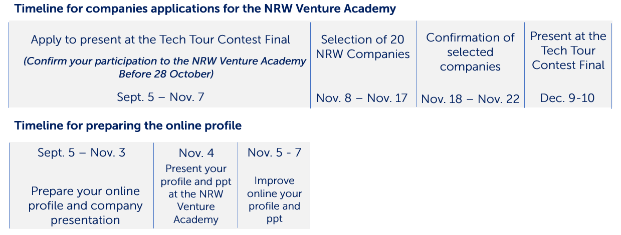

Your benefits if selected as presenting company for the Contest Final:

- Prestigious presenting opportunity followed by valuable feedback from investors on Dec. 10
- Access to the CEO’s only event: Collaborative Academy and Master Classes on Dec. 9
- Invitation only event for promising entrepreneurs and investors with a ratio of 1:1
- Networking with corporate contacts, VCs & fast-growing companies
- Visibility through website, company profile & conference binder

REGISTER
for the NRW Venture Academy (Deadline Oct. 28th)
and for the Tech Tour Contest Final (Deadline Nov. 7th)

We hope you will express your interest in taking part to the event, and remain at your disposal should you have any further questions.

Best regards,
Annalisa on behalf of the Tech Tour Contest Final team

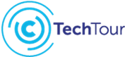 | Annalisa Gardella  Team Leader
 | Offices in Brussels,  Geneva and Sofia | T  E  W | +32 2 643 3691  annalisa@techtour.com  www.techtour.com

Connect with us

For more information on our upcoming events please visit www.techtour.com/events

